A000-AM,C-Taino-Cemi-Fire God-Marble-1000 CE

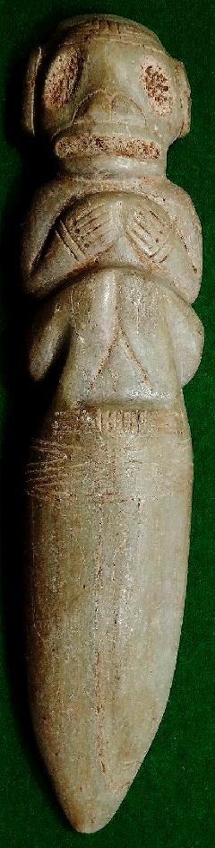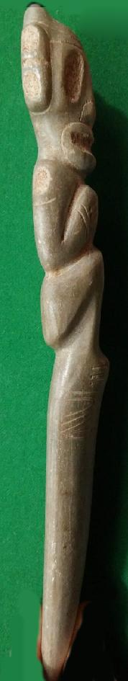 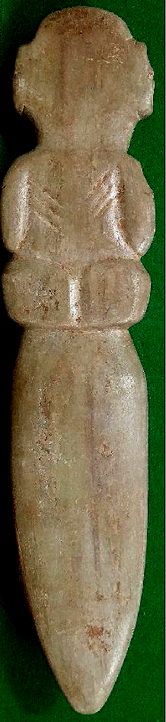

AM,C-Taino-Cemi-Fire God-Marble-1000 CE

Case No.: 18

**Accession No.**

**Formal Label:** AM,C-Taino-Cemi-Fire God-Marble-1000 CE

**Display Description:**

Fire God in its characteristic pose (Fewkes 1907)

**LC Classification: F1909**

**Date or Time Horizon: 1000 CE**

**Geographical Area: Caribbean**

**Map:**

**GPS coordinates:**

**Cultural Affiliation:**

**Medium: marble**

**Dimensions: L 12.5 cm**

**Weight:**

**Condition:**

**Provenance:**

**Discussion:**

**References:**

### 